Microsoft Azure
1. What is Cloud Computing?
Professional Definition
Cloud Computing is the on-demand delivery of computing services such as servers, storage, databases, networking, software, analytics, and artificial intelligence over the internet, allowing users to access these resources without owning or maintaining physical infrastructure.
Cloud service providers like Microsoft Azure, Amazon Web Services (AWS), and Google Cloud Platform (GCP) manage the underlying infrastructure, while users pay only for the resources they consume.
Key Features
- On-demand resource provisioning
- Pay-as-you-go pricing
- Scalability and elasticity
- High availability
- Global accessibility
- Managed infrastructure
Example
Instead of purchasing and maintaining a physical server to host a website, an organization can deploy it on Microsoft Azure and pay only for the computing resources used.

2. What are the Advantages of Microsoft Azure?
Professional Definition
Microsoft Azure is Microsoft's cloud computing platform that provides a comprehensive collection of cloud services for building, deploying, and managing applications through Microsoft's global network of data centers.
Advantages
1. Scalability
Azure enables organizations to increase or decrease computing resources based on business requirements without purchasing additional hardware.

2. Cost Efficiency
Azure follows a pay-as-you-go pricing model, allowing businesses to pay only for the resources they consume.

3. High Availability
Azure provides built-in redundancy and disaster recovery capabilities, ensuring applications remain available even during hardware or regional failures.

4. Security and Compliance
Azure offers enterprise-grade security features such as:
- Identity and access management
- Data encryption
- Firewall protection
- Compliance with international standards (ISO, GDPR, HIPAA, etc.)

5. Global Infrastructure
Azure operates multiple data centers across different geographic regions, enabling organizations to deploy applications closer to users for lower latency and better performance.

6. Wide Range of Services
Azure provides numerous cloud services including:
- Virtual Machines
- Azure Storage
- Azure SQL Database
- Azure Data Factory
- Azure Databricks
- Azure Kubernetes Service
- Azure AI Services

7. Easy Integration
Azure integrates seamlessly with Microsoft products such as:
- Windows Server
- Active Directory
- Microsoft 365
- Visual Studio
- GitHub

3. What is Hosting in Azure?
Professional Definition
Hosting in Azure refers to deploying and running applications, websites, APIs, databases, or virtual machines on Microsoft Azure's cloud infrastructure, making them accessible over the internet.
Azure manages the underlying hardware, networking, storage, and security, while users deploy and manage their applications.
Types of Azure Hosting
- Azure Virtual Machines
- Azure App Service
- Azure Kubernetes Service (AKS)
- Azure Static Web Apps
- Azure Functions (Serverless)
Example
A company develops an e-commerce website and hosts it on Azure App Service, allowing customers worldwide to access the application through the internet.

4. What is IaaS, PaaS, and SaaS?
Cloud services are generally classified into three service models based on the level of responsibility shared between the cloud provider and the customer.

IaaS (Infrastructure as a Service)
Definition
Infrastructure as a Service (IaaS) provides virtualized computing resources such as virtual machines, storage, and networking over the internet.
The cloud provider manages the physical infrastructure, while the customer is responsible for managing the operating system, middleware, applications, and data.
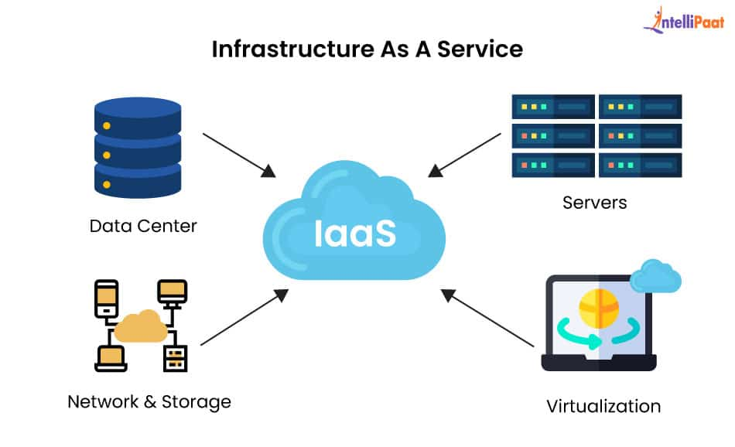
Customer Manages
- Operating System
- Applications
- Runtime
- Data
Cloud Provider Manages
- Physical servers
- Storage
- Networking
- Virtualization
Azure Example
- Azure Virtual Machine
- Azure Virtual Network
- Azure Managed Disks

PaaS (Platform as a Service)
Definition
Platform as a Service (PaaS) provides a complete platform for developing, testing, deploying, and managing applications without managing the underlying infrastructure.
The cloud provider manages the servers, operating system, runtime, and middleware, allowing developers to focus only on writing application code.
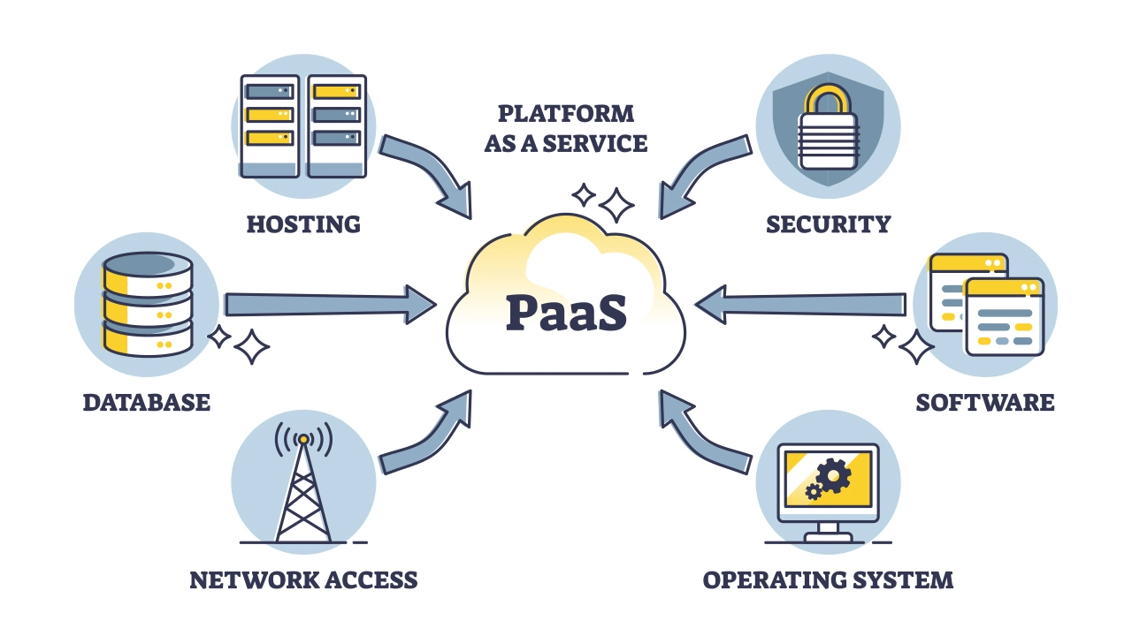
Customer Manages
- Application code
- Data
Cloud Provider Manages
- Infrastructure
- Operating System
- Runtime
- Middleware
- Networking
Azure Example
- Azure App Service
- Azure SQL Database
- Azure Functions

SaaS (Software as a Service)
Definition
Software as a Service (SaaS) delivers fully functional software applications over the internet. Users simply access the application through a web browser or client application without installing or maintaining the software.
The cloud provider manages the complete application and infrastructure.
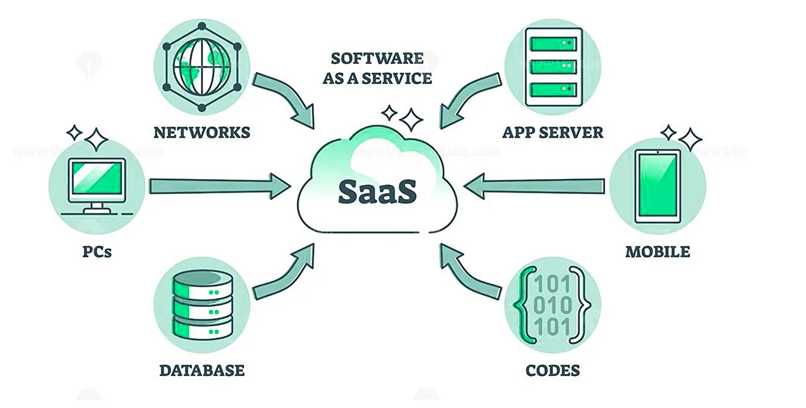
Customer Manages
- User settings
- Application usage
Cloud Provider Manages
- Application
- Infrastructure
- Updates
- Security
- Maintenance
Examples
- Microsoft 365
- Gmail
- Salesforce
- Dropbox
- Zoom

Comparison of IaaS, PaaS, and SaaS
Feature | IaaS | PaaS | SaaS
Infrastructure Managed By | Cloud Provider | Cloud Provider | Cloud Provider
Operating System Managed By | Customer | Cloud Provider | Cloud Provider
Runtime Managed By | Customer | Cloud Provider | Cloud Provider
Application Managed By | Customer | Customer | Cloud Provider
User Responsibility | Infrastructure configuration and application management | Application development and deployment | Using the software
Azure Example | Azure Virtual Machine | Azure App Service | Microsoft 365

